Ex: Country=UK

User Given attribute.  
User_given_Attribute__mdt

User

*e.g: coumtry=’UK’*

user derived mapping

User_derived_attribute__mdt

user attribute mapping

User_attribute_mapping__mdt

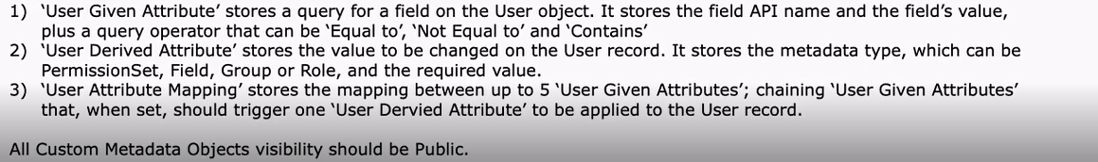

|  |  |  |  |  |  |  |  |
| --- | --- | --- | --- | --- | --- | --- | --- |
|  | **Field Label** | **API Name** | **Data Type** | **Field Manageability** | **Indexed** | **Controlling Field** | **Modified By** |
|  | [Derived Attribute](https://pagegroup--ccdev.my.salesforce.com/00N4J00000BQ9Nr?setupid=CustomMetadata) | UserDerivedAttribute__c | Metadata Relationship(UserDerivedAttribute) | Upgradable | Checked |  | [Kalyani Mamillapalli](https://pagegroup--ccdev.my.salesforce.com/0051t000002u30D), 27/07/2019 20:55 |
|  | [For Unit Test](https://pagegroup--ccdev.my.salesforce.com/00N3M000000PEMV?setupid=CustomMetadata) | For_Unit_Test__c | Checkbox | Upgradable |  |  | [Abhi Patel](https://pagegroup--ccdev.my.salesforce.com/0053M000000Hl5d), 20/07/2020 07:27 |
|  | [Given Attribute 1](https://pagegroup--ccdev.my.salesforce.com/00N4J00000BQ9Ns?setupid=CustomMetadata) | UserGivenAttribute1__c | Metadata Relationship(UserGivenAttribute) | Upgradable | Checked |  | [Kalyani Mamillapalli](https://pagegroup--ccdev.my.salesforce.com/0051t000002u30D), 27/07/2019 20:55 |
|  | [Given Attribute 2](https://pagegroup--ccdev.my.salesforce.com/00N4J00000BQ9Nt?setupid=CustomMetadata) | UserGivenAttribute2__c | Metadata Relationship(UserGivenAttribute) | Upgradable | Checked |  | [Kalyani Mamillapalli](https://pagegroup--ccdev.my.salesforce.com/0051t000002u30D), 27/07/2019 20:55 |
|  | [Given Attribute 3](https://pagegroup--ccdev.my.salesforce.com/00N4J00000BQ9Nu?setupid=CustomMetadata) | UserGivenAttribute3__c | Metadata Relationship(UserGivenAttribute) | Upgradable | Checked |  | [Kalyani Mamillapalli](https://pagegroup--ccdev.my.salesforce.com/0051t000002u30D), 27/07/2019 20:55 |
|  | [Given Attribute 4](https://pagegroup--ccdev.my.salesforce.com/00N4J00000BQ9Nv?setupid=CustomMetadata) | UserGivenAttribute4__c | Metadata Relationship(UserGivenAttribute) | Upgradable | Checked |  | [Kalyani Mamillapalli](https://pagegroup--ccdev.my.salesforce.com/0051t000002u30D), 27/07/2019 20:55 |
|  | Given Attribute 5 | UserGivenAttribute5__c | Metadata Relationship(UserGivenAttribute) | Upgradable |  |  |  |

User trigger logic:

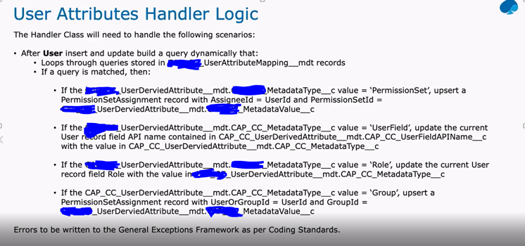

e.g: of userattributemapping

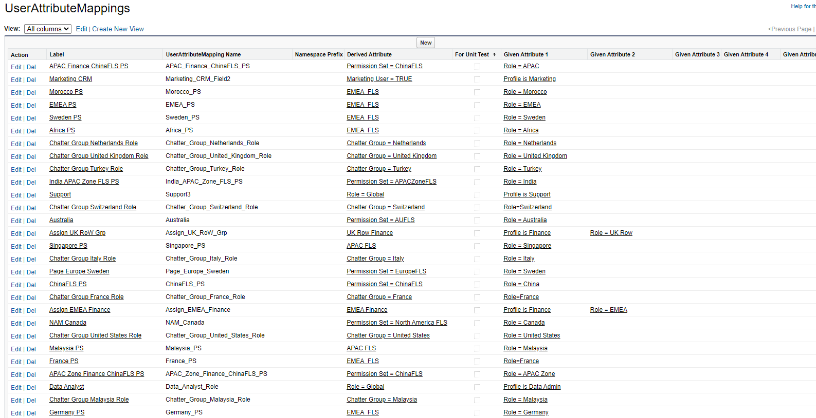

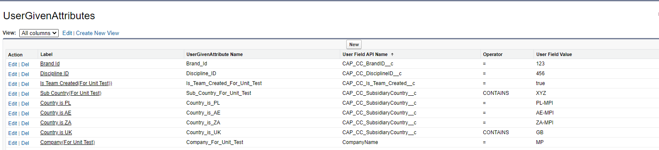

User derived attribute:

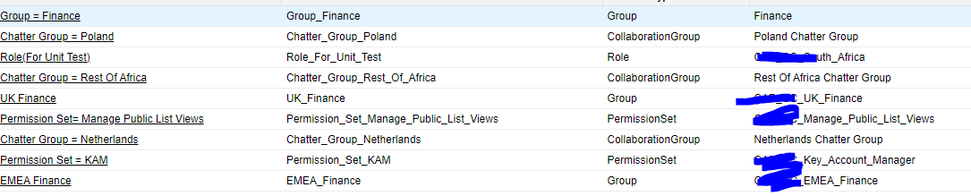

User trigger: